A **confusion matrix is a table** layout that compares the actual labels with the predicted labels.

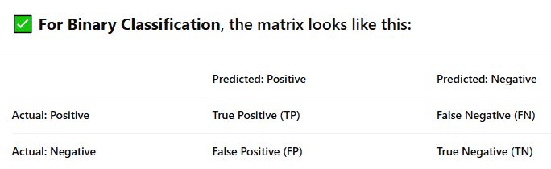

• **TP (True Positive)**: Model predicted **Positive**, and it **was** Positive.

• **TN (True Negative)**: Model predicted **Negative**, and it **was** Negative.

• **FP (False Positive)**: Model predicted **Positive**, but it **was** Negative. (Type I error)

• **FN (False Negative)**: Model predicted **Negative**, but it **was** Positive. (Type II error)

